Pardner Hand: A Caribbean answer to British banking exclusion
An exhibition from Museumand, The National Caribbean Heritage Museum

Key stage 3 English: reading critically and referring to evidence in a text.

Task 1

As you watch the testimonials, note down your answers to these questions.
Hurley
Why did Hurley open a bank account?

Kayan
Can you find three pieces of evidence which suggest that Pardner Hand works as a system of trust?

Lenny
What potential risk does Lenny identify within Pardner Hand?

Colin
What does Colin’s testimony reveal about how Pardner Hand has developed over time?

What conclusions can we draw from the testimonials about the role of Pardner Hand, and saving schemes more generally, and the way they can impact people’s lives?

Task 2
To what extent did Pardner Hand differ from the existing borrowing and savings accounts available in the UK in the 1950s?
You may wish to include:
- The key features of Pardner Hand
- The key features of traditional UK borrowing and saving accounts
- The similarities and differences between the Pardner Hand and traditional UK borrowing and savings accounts
- Why Pardner Hand was popular with Windrush migrants

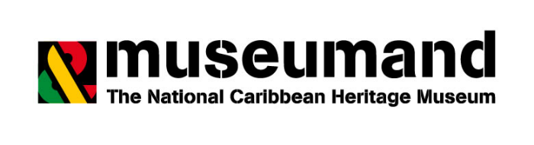

Task 3
Read the poem, written by Phyllis Chase, below. Identify how it supports the idea that Pardner Hand was pivotal in helping the Windrush migrants to settle in Britain.

When I came to England many years ago, rooms were hard to get. Not many places to go. Wages were low. Money we could not save. We had to find ways to invest and be brave.
The Pardner became a sensible option. To throw two hands in 20 would change the situation. I made friends with strangers. I learned the ropes. I shared knowledge and learned other ways to cope.

We joined together and thirty of us joined in a £10 hand.

Each week, one person would get £300 in their hand. I was five in line to receive my money this time.

When all hands that were entered became mine

I was happy and shocked at having so much money. I planned to spend it to the best of my ability. Sometimes I made plans to buy a new home. I could now settle down, no more will I roam.

I now need a bed and a cooker so that I can cook and eat. I was thinking very fast on my feet. I had sleepless nights. I could not settle. To accumulate more money Now became a battle.

I will continue to take part in the Pardner project as many problems can be solved with it. I developed a sense of security in my heart, and the community will prosper from the start.

Phyllis Chase is a Watford resident, she was born in Christchurch, Barbados. Phyllis came to the UK in 1962 to study nursing.

You can find out more about the exhibition by visiting our website.

