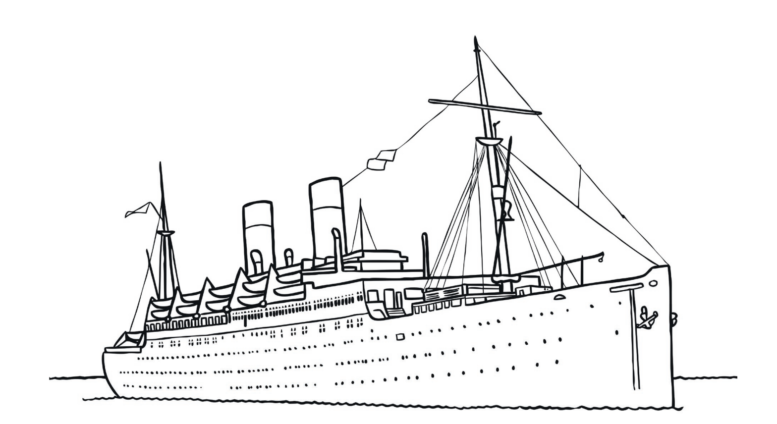
HMT EMPIRE WINDRUSH

On 22 June 1948, the HMT Empire Windrush arrived at Tilbury Docks in Essex, carrying passengers from across the Caribbean, answering Britain’s call for workers following the Second World War. The people on the ship were among the first of what would become known as the Windrush Generation.

